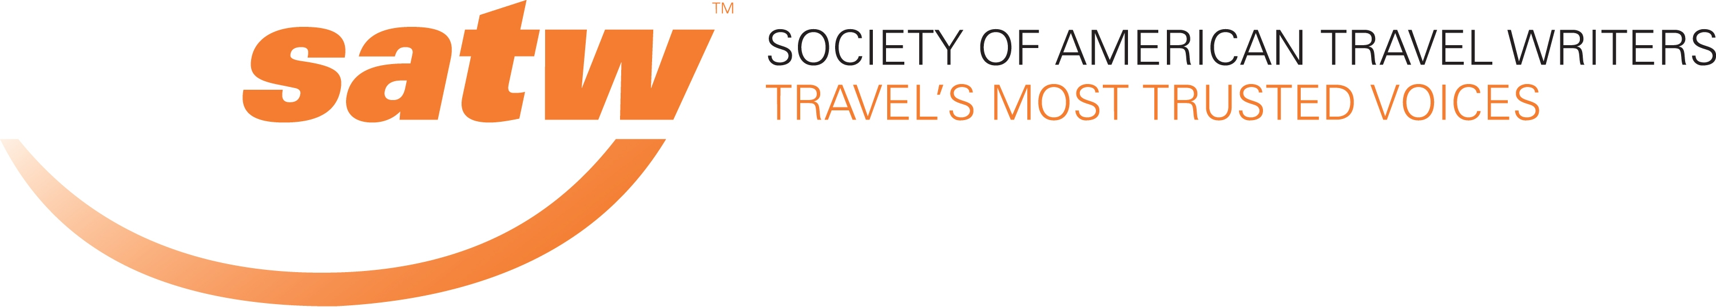

SATW Member Benefit Agreement

Company or Organization: the Globus family of brands (Globus, Cosmos, Monograms and Avalon Waterways)

Contact Name: SATW Active member Martha Chapman c/o Tourism Marketing International, 3 Mountbatten Road, Toronto ON M9P 1Y8, Canada. mchapman@tourismmarketing.ca; 1-416-614-2845

Description of Benefit: 20 per cent off brochure price of any Globus family of brands vacation package or river cruise. Affordable airfares are also available through your Globus family booking agent, however fares are not eligible for a discount.

Note the discount is not combinable with any sale or discounted product but may be combined with the Journeys Club 5 per cent discount for repeat passengers of any Globus family of brands company. However travellers are welcome to take advantage of any sale prices which may be in effect at time of booking should the offer be greater than 20%.

The discount also applies to all members of the party travelling on the identical itinerary with the SATW member.

This benefit may not be claimed if you are booking through a travel agent: you must book through Globus family of brands directly (U.S. and Canadian contact numbers below).

Product description: With nearly 90 years experience in worldwide touring, Switzerland-headquartered Globus family of brands is one of the world’s leading travel organizations.

Their products are divided into four distinct categories:

Globus: escorted motorcoach touring in Europe (plus Israel and Jordan), North, South and Central America, Africa, Asia, Australia and New Zealand.

Cosmos: value priced motorcoach touring in Europe (plus Morocco), North America, South America and Asia.

Monograms: packaged travel for independent travellers in Europe, South & Central America, Asia, Australia & New Zealand and Africa. Monograms takes care of all the itinerary details and includes the services of a Local Host. A sample itinerary would be Paris & London in a week including EuroStar train between the cities, breakfast daily and a half-day sigihtseeing tour in each city.

Avalon Waterways: Intimate and stylish river cruising throughout Europe, the Amazon, China/Yangtze, Myanmar and Vietnam & Cambodia/Mekong.

Faith-based Tours: Special escorted tours from Globus and Cosmos itineraries in Europe, the Middle East and Mexico geared to the Christian traveller

For more information and to request complimentary brochures:

In the USA In Canada
with Canadian dollar pricing

avalonwaterways.com avalonwaterways.ca
cosmos.com cosmosvacations.ca
globusjourneys.com globusjourneys.ca
monograms.com monogramstravel.ca

For reservations from the US: For reservations from Canada:
877-245-6287 416-915-6743

Specify that you are an SATW member. This will be verified

This benefit may be withdrawn at any time by the Globus family of brands, though any member holding a confirmed reservation at that time will have his/her trip honoured.

November 21, 2015

