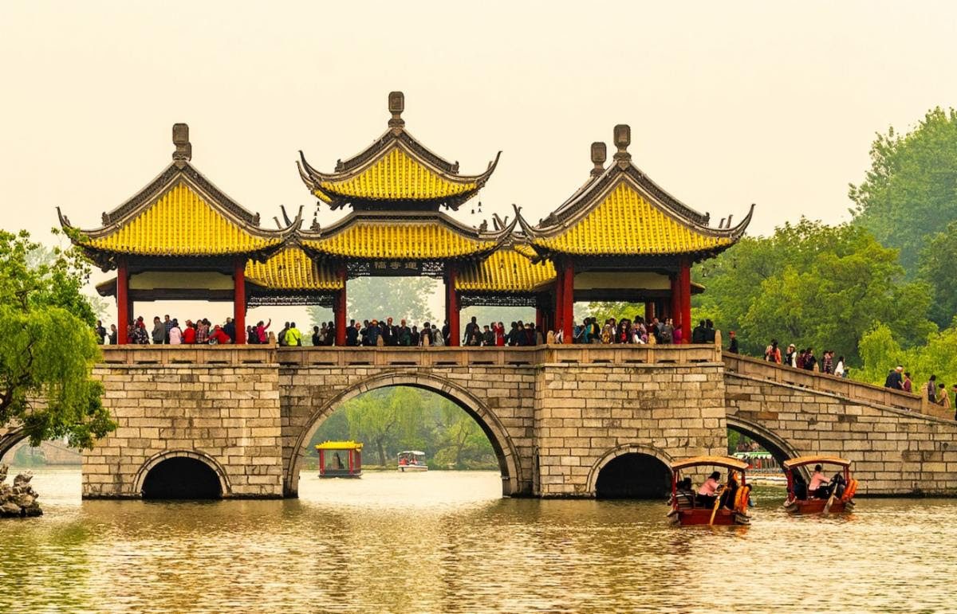

For Immediate Release
Contact: Victoria Larson
victoria@vklarsoncommunications.com
917-678-7689

The Society of American Travel Writers (SATW)
Announces the 2020 Winners of the Distinguished Phoenix Awards

New York, NY - October 16, 2020 - Tourism initiatives in China, Mexico and the U.S. have been recognized for superior sustainability efforts in the 2020 SATW Phoenix Awards.

Founded in 1969, the Phoenix Awards recognize and honor destinations that showcase responsible, sustainable tourism, including conservation; preservation; beautification and anti-pollution efforts as they relate to travel. Though travel was halted for much of this pandemic year, North America's premier travel media organization has maintained its long-standing focus on sustainability while appreciating the benefits of cultural understanding and economic activity that come with travel.

Awardees may be individuals, communities or organizations that have contributed to a quality travel experience through conservation, preservation, beautification or environmental efforts. Nominations must be made by SATW members; they are then reviewed by the SATW Phoenix Committee and submitted with recommendations to the Board of Directors for final approval.

"SATW is proud to continue our long-standing focus on natural and cultural sustainability," said Jane Wooldridge, SATW President. "Though over-tourism is not a pressing issue in this COVID year, SATW understands that travelers are anxious to return to their favorite places and search out new destinations. We will continue to encourage them to do so with a light footprint and to honor the destinations that emphasize sustainability."

The four 2020 winners are:

Yangzhou Historic District and Gardens, Yangzhou City, Jiangsu Province, China
Located in the southeastern part of China adjacent to Shanghai, the city of Yangzhou dates back over 2,500 years. Unlike some other modern cities in China that have demolished their past and replaced old buildings with skyscrapers, Yangzhou has preserved its historic core of precious ancient buildings, its ancient "hutongs" or alleyways, and kept its 1200-years-old Dongguan Street free of high-rise hotels and cars. Tourists strolling along Dongguan Street today can see and visit over 50 historic buildings and sites, including wealthy salt merchants' houses, temples, century-old shops, and some 200 historic gardens that are scattered beyond the ancient, historic core. The City of Yangzhou has involved local residents and the local horticultural society to educate "newcomers" to maintain traditional garden horticulture and arrange private guided tours for visitors. The efforts of preserving and beautifying Historic Yangzhou and its gardens are still works in progress. Located one hour from Shanghai by train, Yangzhou is easy to visit on a day trip.
https://whc.unesco.org/en/tentativelists/5327/

Guachimontones Archeological Site and Interpretive Center, Teuchitlan Municipality, Jalisco State, Mexico
Guachimontones is a major pre-Columbian archaeological site dating from 300 BCE to 450/500 CE, that was unearthed outside of Guadalajara in Teuchitlan, Mexico. It was discovered in 1969 by American archaeologist Dr. Phil Weigand and his wife Celia Weigand, who together initiated excavation and a research facility. The site is significant for its unique circles (remaining foundations of conical pyramids) as well as circular patios, a ball court, terraces and buildings. Guachimontones, part of the Agave Landscape and Ancient Industrial Facilities of Tequila (ancient tequila distilleries), was declared a UNESCO World Heritage Site. Also, in 2008, the site was listed in the World Monuments Watch List of 100 Most Endangered Sites for preservation against looting.

Today the reconstructed site and Museum/Interpretive Center (which includes the science research hub) have shifted from electric energy to sustainable solar energy and sustainable waste treatment facilities. The Museum/ Interpretive Center educates visitors about the lost culture and ceremonial settlement, aiming to cultivate respectful attitudes for pre-Hispanic heritage, the Teuchitlan society that occupied today's Nayarit and Jalisco lands, and how human behavior has changed over time. The Interpretive Center gives panoramic views of the Tequila valley, volcano and river. This site generates great pride among Teuchitlan community locals, many of whom are involved in tourism related services, including transportation, tours and restaurants. Archeologists continue to explore and excavate. Guachimontones site and Interpretive Center welcomes 170,000 visitors annually. Guachimontones Archeological Site and Interpretive Center, Teuchitlan Municipality, Jalisco State, Mexico

Gulf State Park, Alabama, USA
Since the Deepwater Oil Spill in 2010 - one of the worst man-made disasters in US History - the Gulf State Park in Alabama has been totally transformed, becoming an international showcase for environmental and economic sustainability as it demonstrates best practices for outdoor recreation, education and hospitable accommodations. One of the Gulf State Park's impressive practices is to help dunes regenerate by planting berms out of fencing and burying discarded Christmas trees so wind-borne sand may accumulate and form new dunes, thereby increasing habitat for the endangered Alabama Beach Mouse, nesting sea turtles, and shore birds.

The park is designed as a municipal water authority to collect and maintain fresh water through cisterns. Within the park, the Interpretive Center (LEED Platinum certified) introduces visitors to the entire 6,500-acre site and nine different ecosystems. Its expanded biking trail system complies with environmental and accessibility guidelines. The new Hilton-branded Lodge boasts environmental certifications of LEED Gold, SITES Platinum landscape for native and sustainable landscape design, and FORTIFIED Commercial resiliency program. The park's existing 11 cottages were refurbished and have since been listed among National Geographic Unique Lodges of the World. To enhance the park's tourism draw, the City of Gulf Shores is adding the Gulf Coast Center for Ecotourism & Sustainability (opening in 2022) to include educational programs created by Jean-Michele Cousteau and his Ocean Futures Society. Gulf State Park, Alabama, USA

Falls Park on the Reedy, City of Greenville, South Carolina, USA
Falls Park on the Reedy is a 26-acre park that transformed the Reedy River and surrounding lands that had been polluted from decades of industrial waste pouring from grist mills and textile mills. The park greatly revitalized and impacted the City of Greenville, making it a delightful tourism destination and inspiring hub for local artisans. Today the park mingles nature trails and a pedestrian suspension bridge overlooking a waterfall with cultural attractions including amphitheaters for concerts and Shakespearean performances, and nearby, the South Carolina Governor's School for the Arts and the West End Market. Cleansing the river and trashed lands was a difficult, 40-year-long labor of love that started with members of the Carolina Foothills Garden Club, who pulled weeds and pushed back kudzu, raised funds, and inspired a master plan for beautification and preservation. In the process, they replaced a derelict bridge with a new suspension bridge, and created Reedy River Falls Historic Park, which is listed on the National Register of Historic places. Opened in 2004, Falls Park on the Reedy has become a regional attraction that draws five million annual visitors. Falls Park on the Reedy, City of Greenville, South Carolina, USA

The SATW Membership
Founded in 1955 before the Internet was born and when print media reigned, SATW and its members have adapted continually to meet an-ever changing media landscape. Today, SATW remains the nation's premier professional travel media organization comprising 1,000 of the travel industry's most experienced journalists, photographers, editors, broadcast/video/film producers, bloggers, website owners, media relations experts and hospitality industry representatives from the United States, Canada and beyond. All members must meet and maintain the industry's highest standards of productivity, ethics and conduct, and support SATW's mission of "Inspiring Travel through Responsible Journalism."

A Welcoming and Vibrant Community
SATW is a vibrant resource in and to the travel industry for bringing travel media and destinations together. It is a community where professionals have meetings that result in business but also where professionals can come together to share peer-to-peer best practices, experiences and build relationships.

In this pivotal year, SATW has continued serving its membership through ongoing professional development. It also has championed the ongoing struggle for racial equality with formal statements of diversity, equity and inclusion publicly welcoming all races, religions, ethnicities, physical abilities and the LBGTQ community. This initiative is supported by an active Diversity, Equity, Accessibility and Inclusion Committee, which presents programs on diversity and seeks to ensure membership is inclusive and welcoming to all professionals.

MEDIA REQUESTS: For additional information and interviews with SATW President Jane Wooldridge, incoming SATW President Larry Bleiberg, contact SATW's External Communications Manager, Victoria Larson, victoria@vklarsoncommunications.com.
For information about SATW and its membership, contact SATW Executive Director Marla Schrager, mschrager@satw.org. For information about the Phoenix Award, contact Phoenix Chair Toby Saltzman, tobysaltzman@rogers.com.

+++++

